**Smart and Clean Cities - SCC**

**Building the eco future together**

**User manual**

**Belgrade, June 2020.**

Table of Contents

1. Purpose of the document 3

2. Icons used in this document 3

3. Brief description 3

4. Project partners 4

5. Users 4

6. History of the solution 4

7. Structure of the application 5

7.1 Logging in as Municipality 7

7.2 Logging in as Company 11

7.3 Logging in as Driver 15

7.3.1 Account 17

7.3.2 Personal information 18

7.3.3 Car information 19

7.3.4 Favourite destinations 20

7.3.5 Language 21

7.3.6 Send email 22

7.3.7 Find route 23

7.4 Change password 27

# Purpose of the document

This document is designed for all the users of the application to minutely explain how to use it correctly in order to have the best experience possible.

This document is the property of its authors, Anja Pantovic and Jovana Jelcic, and it may not be reproduced or communicated without the authors’ prior agreement.

# Icons used in this document

|  |  |
| --- | --- |
|  | Logout of your account |
|  | Current location |
|  | Routes that can be favourited |
|  | Favourite routes; can be found in favourite locations tab |
|  | Final destination |

# Brief description

Given that the air pollution is getting worse and worse every day, the quality of life is being diminished which has the impact on world’s population and global ecological picture.

The solution we are proposing partially solves this problem. By reducing the concentration of harmful gases by different calculations our system does, every user can contribute in our mission by only couple of clicks.

This application also allows users to indirectly communicate with the main server in order to find the best route through eco territories.

# Project partners

The global partners of this project are:

* Technische Universität München (TUM) - Germany
* Swiss Federal Institute of Technology in Zurich (ETH) - Switzerland
* Universiteit van Amsterdam (UVA) – The Netherlands
* Sauermann Group - USA
* IP Way - Serbia
* Trigg Industries - USA

# Users

Users of this application are:

* Drivers
* Municipalities
* Companies

# History of the solution

|  |  |  |  |
| --- | --- | --- | --- |
| **Date** | **Version** | **Changes** | **Author** |
| **30.06.2020.** | **1.0** |  | **Anja Pantovic Jovana Jelcic** |
|  |  |  |  |

# Structure of the application

On the initial screen user can choose two options:

* Log In – if he already has an account
* 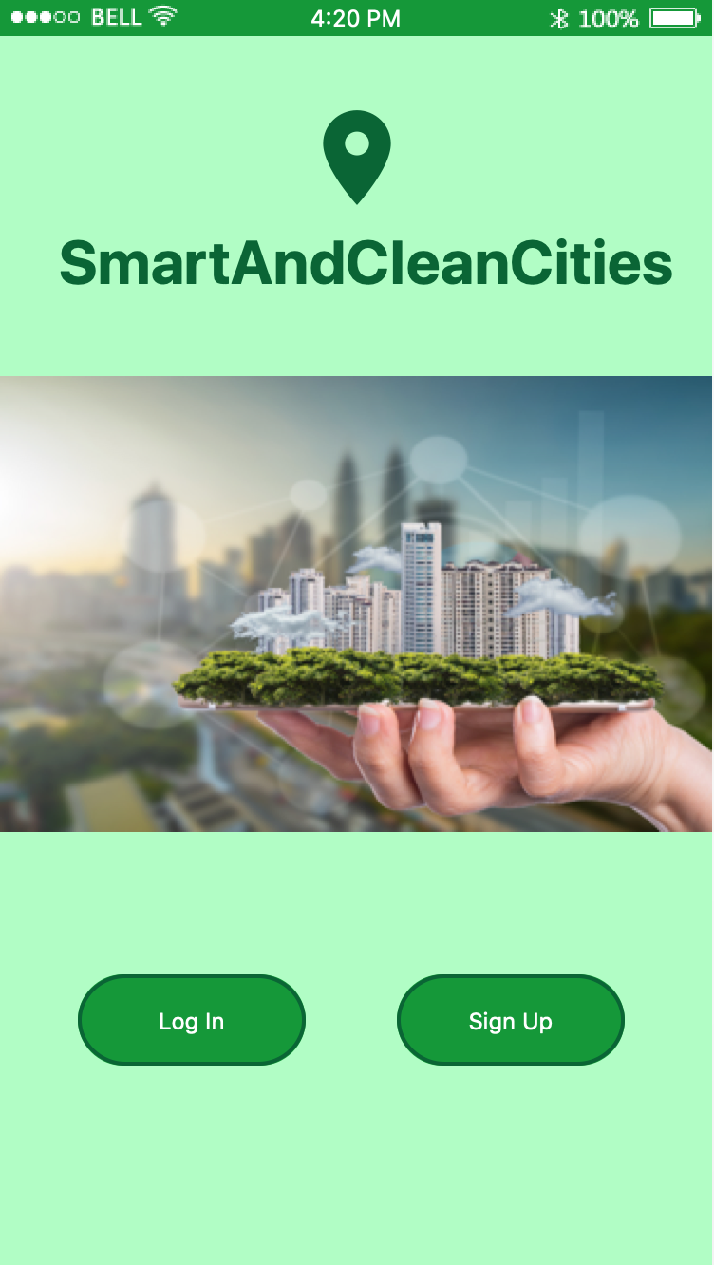Sign Up – to create an account

By choosing *Sign Up* the following screen shows up:

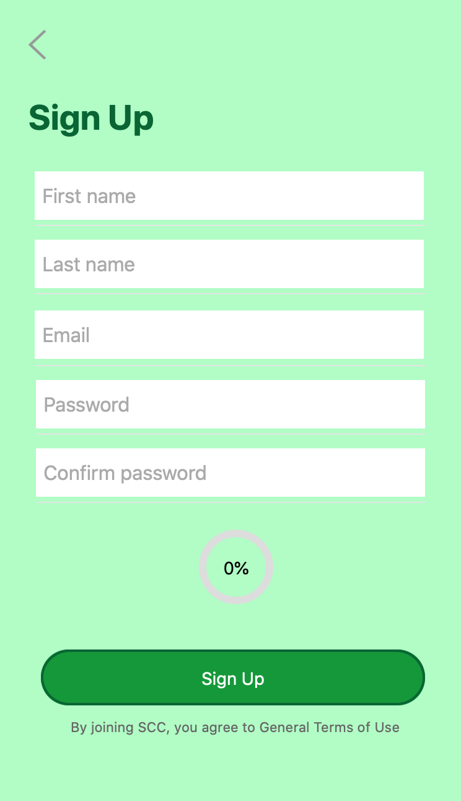

Go back to initial screen

Click to create an account

Percentage of finished work

By choosing Log In on the initial screen, user can choose if he wants to login as municipality, company or driver.

## Logging in as Municipality

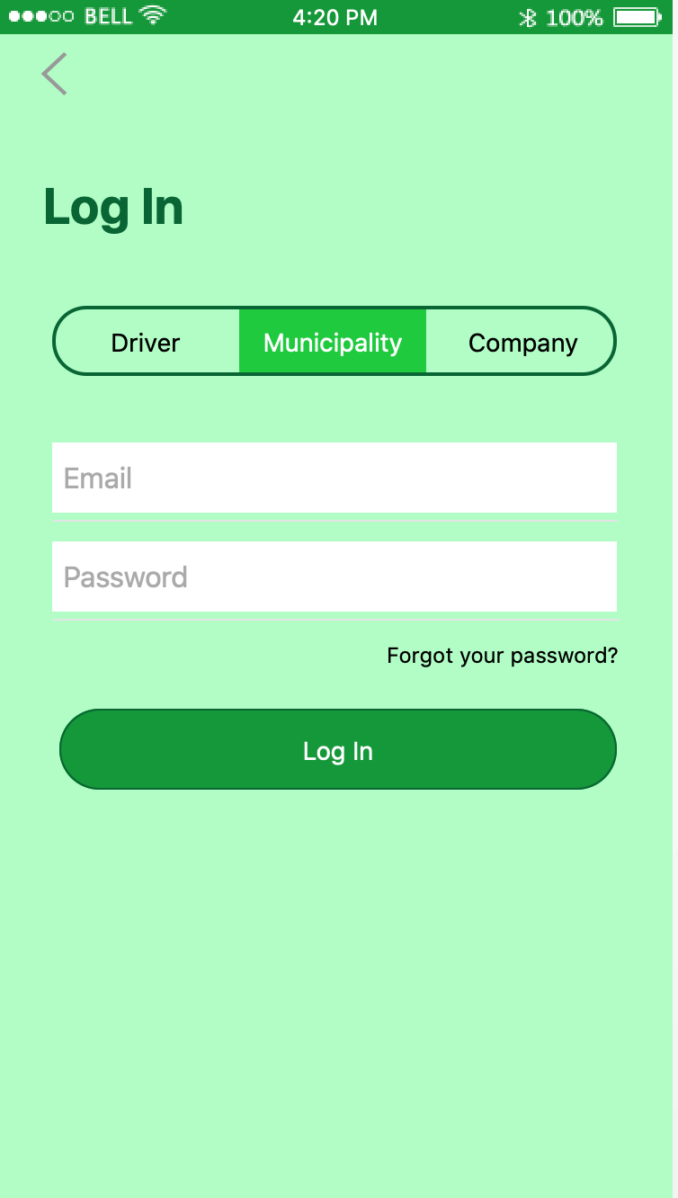

Go back to initial screen

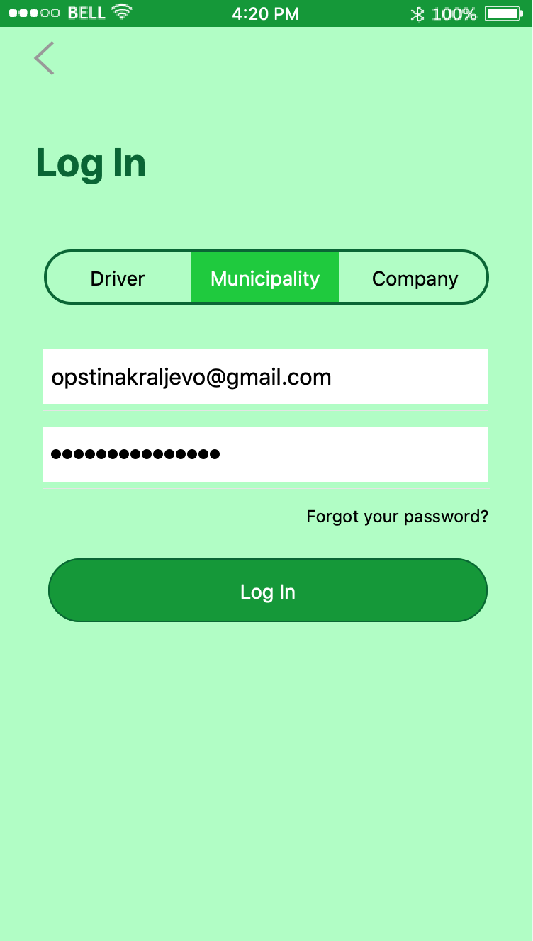

Change password (same for every user)

Go back to initial screen

Click to login and go to your profile (same for every user)

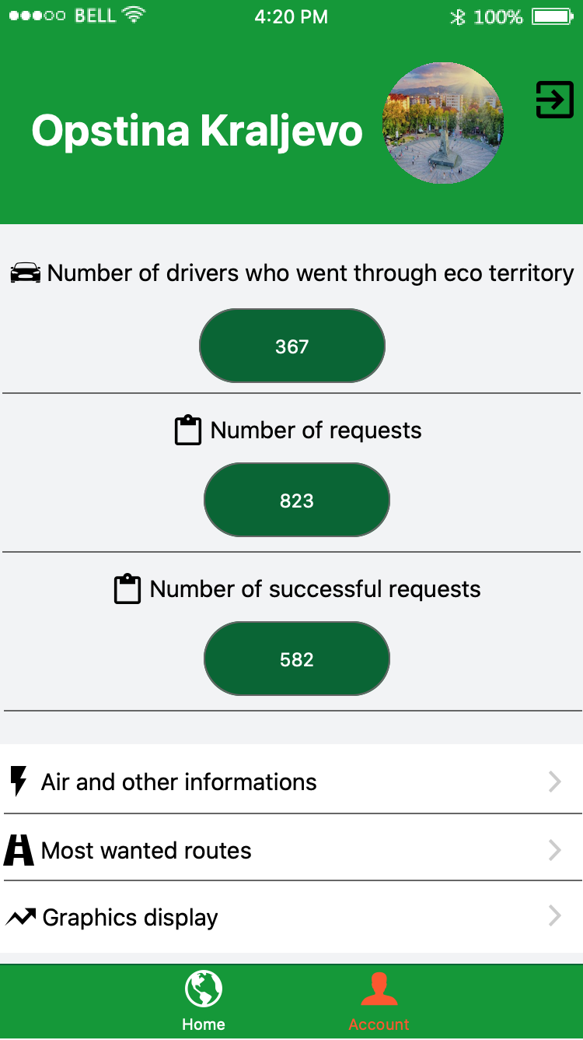

Home page

Different statistical graphic displays

Information about most popular routes

Information about air, vehicles and most popular time

Log out button

Orange if you are on that screen

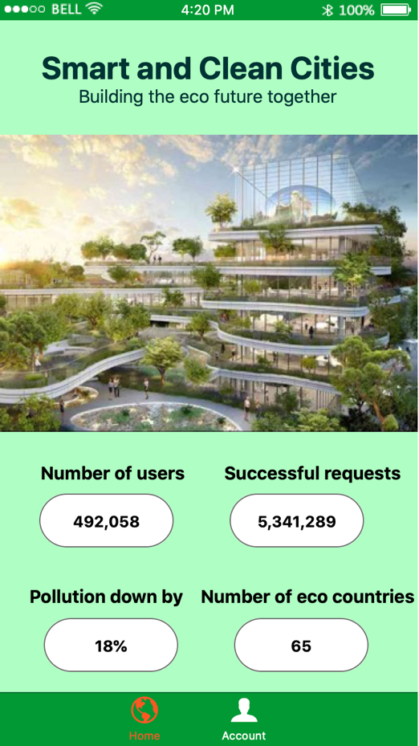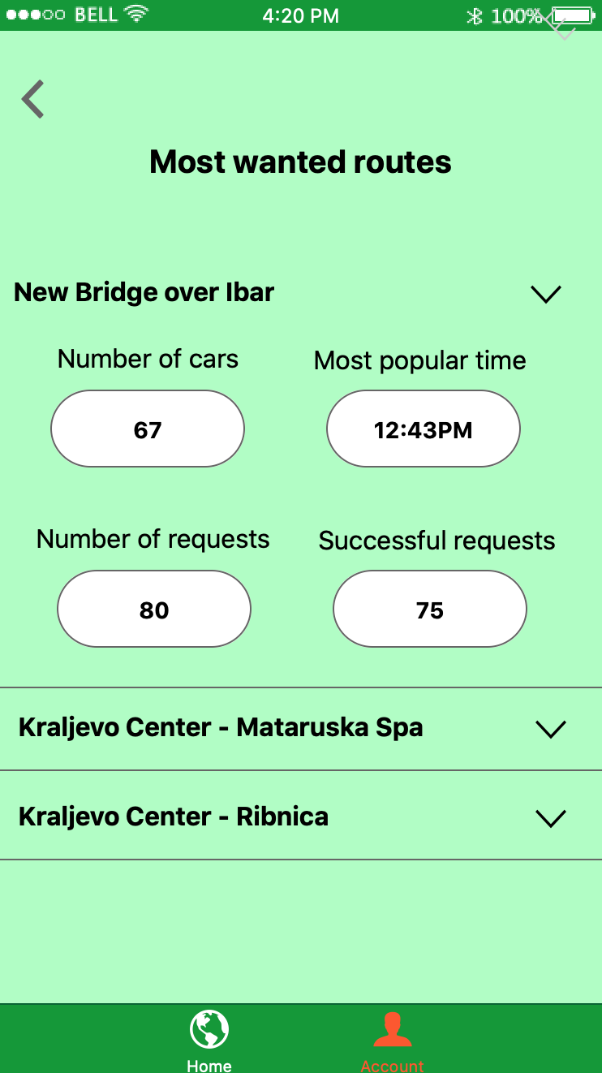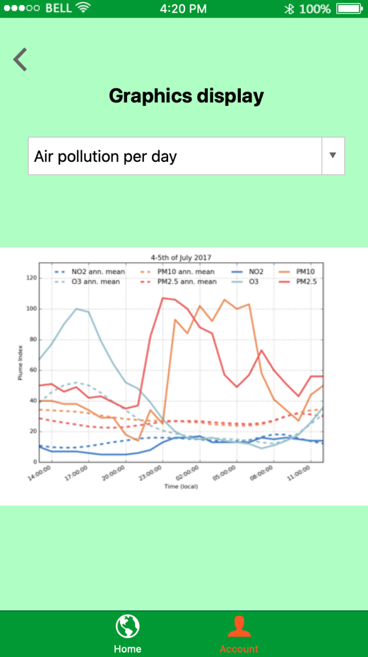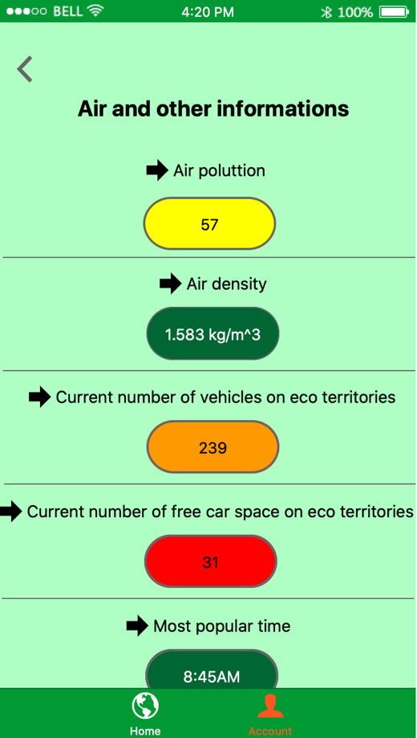

Back to profile

Show details

Change graphic

## Logging in as Company

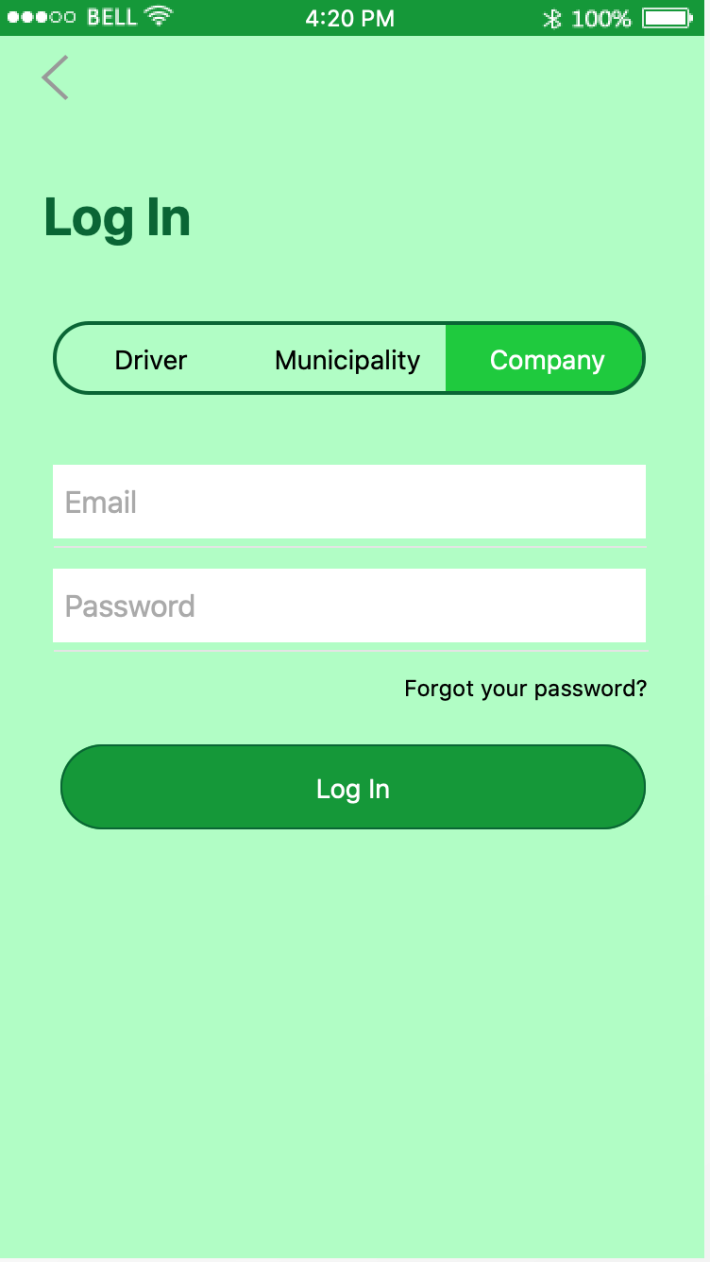

Go back to initial screen

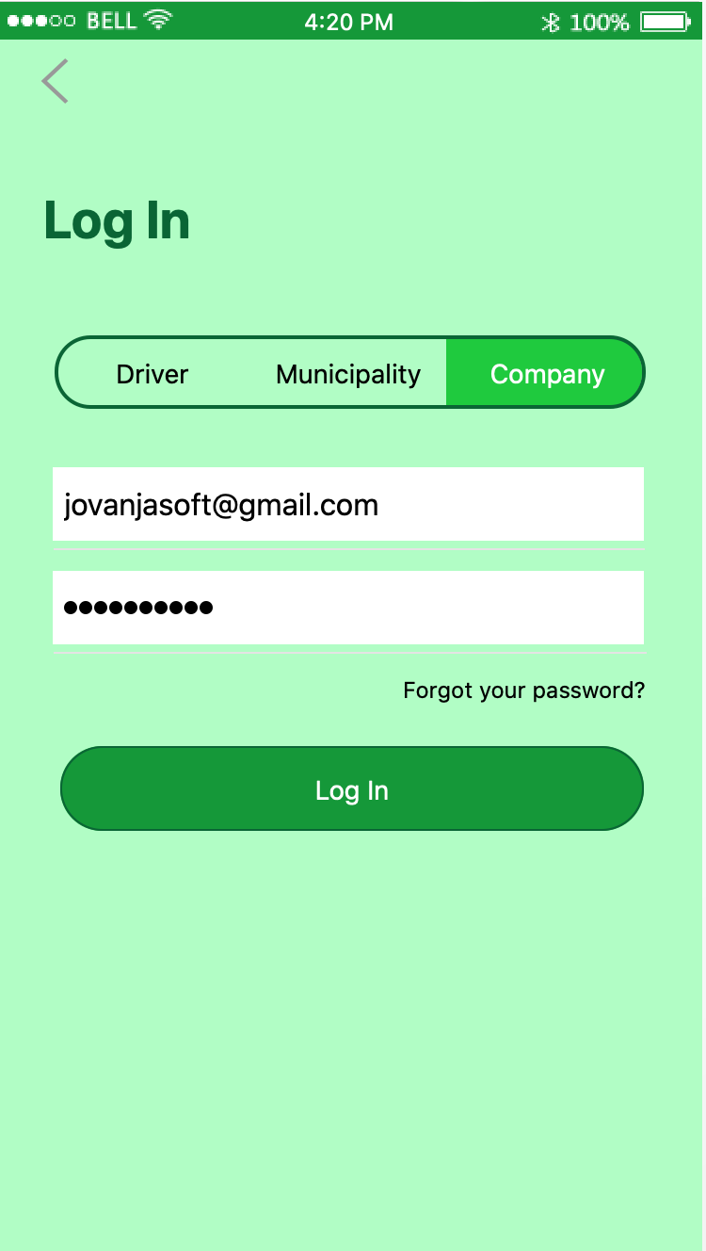

Change password (same for every user)

Click to login and go to your profile (same for every user)

Go back to initial screen

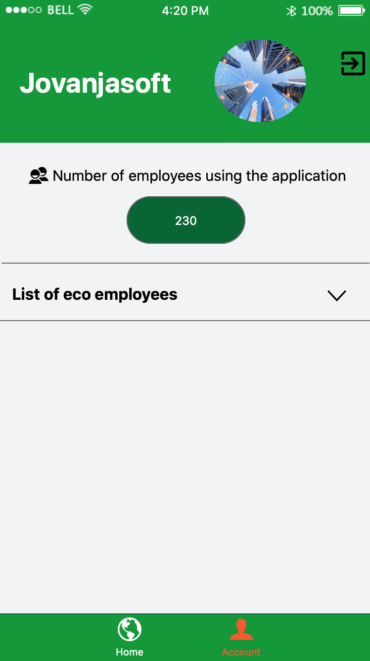

Home page

Log out button

Information of employees using the application

Orange if you are on that screen

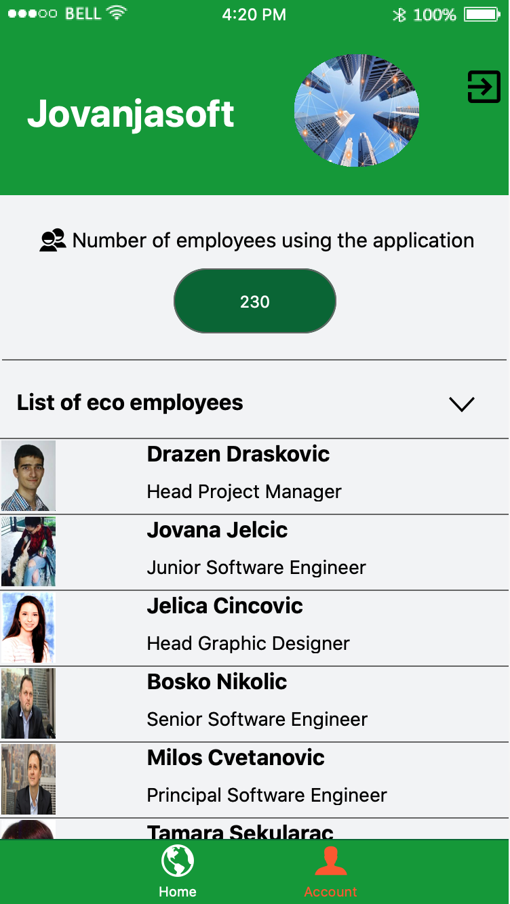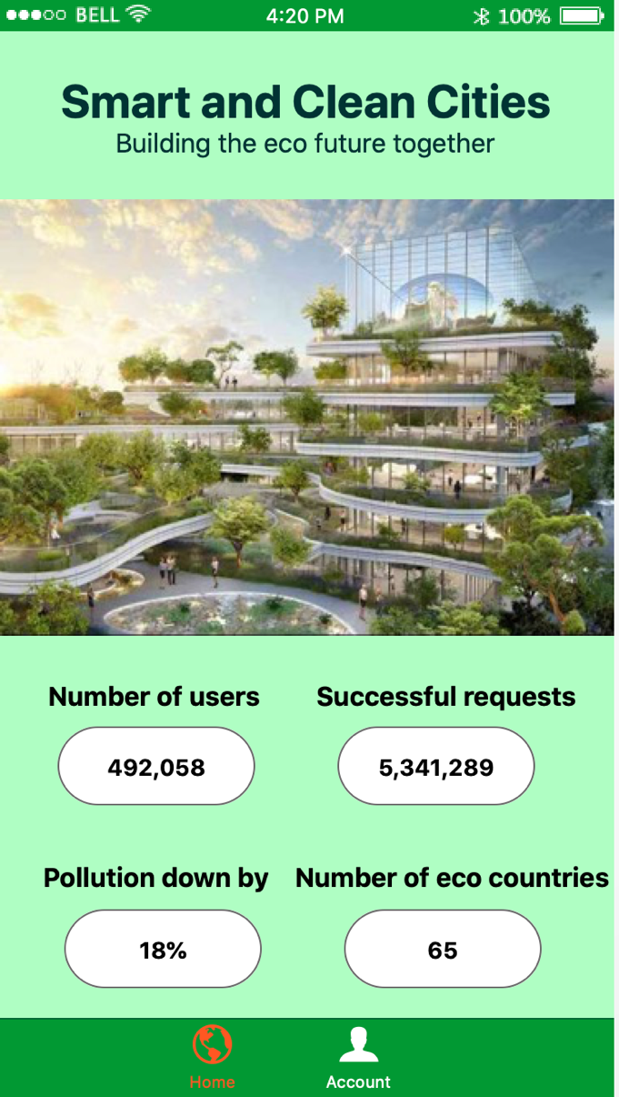

## Logging in as Driver

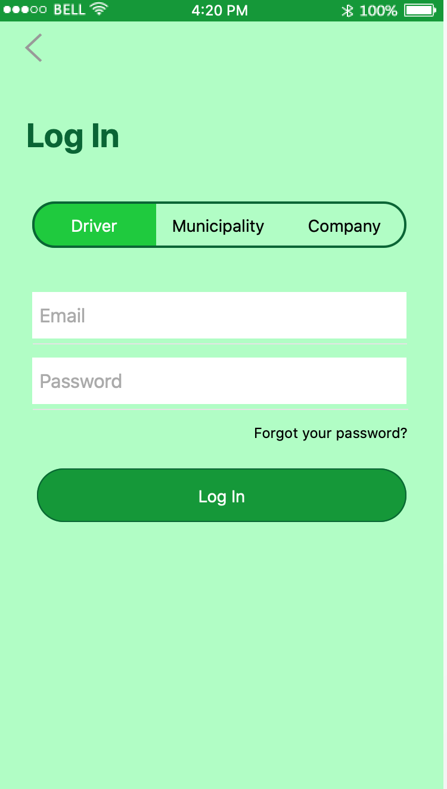

Change password (same for every user)

Go back to initial screen

Click to login and go to your profile (same for every user)

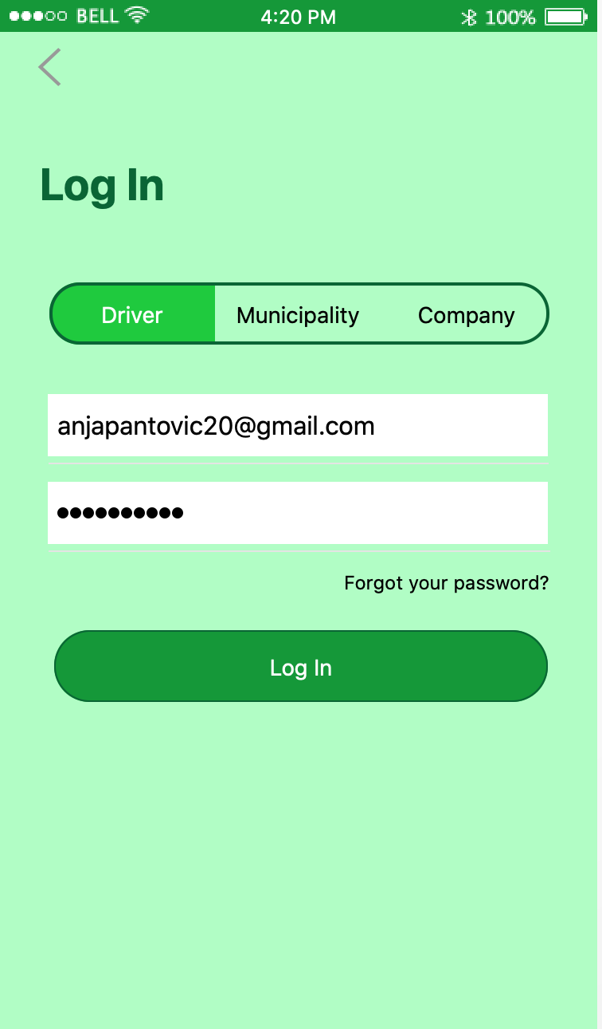

### A screenshot of a cell phone Description automatically generated7.3.1 Account

About the application

Frequently asked questions

Send email to owners

Change language

Click to see or change car information

Click to see or change personal information

Log out

Click to see favourite routes

Profile; orange color shows on which page the user is

Home page

Find the fastest eco route

### A screenshot of a cell phone Description automatically generated7.3.2 Personal information

Confirm changes

Change/Upload profile picture

Back to profile

Change email

Change username (initially user’s first and last name)

Change last name

Change first name

### A screenshot of a cell phone Description automatically generated7.3.3 Car information

Change car registration

Change car type

Confirm changes

Back to profile

Change car brand

### A screenshot of a cell phone Description automatically generated7.3.4 Favourite destinations

Search favourite destinations

Unlike previously favorited destinations

Globally favourite destinations

User’s favourite destinations sorted by country

Back to profile

### A screenshot of a cell phone Description automatically generated7.3.5 Language

Confirm chosen language

Choose language

Back to profile

### A screenshot of a cell phone Description automatically generated7.3.6 Send email

Type email

Send email

Back to profile

### 7.3.7 Find route

1. Initial page

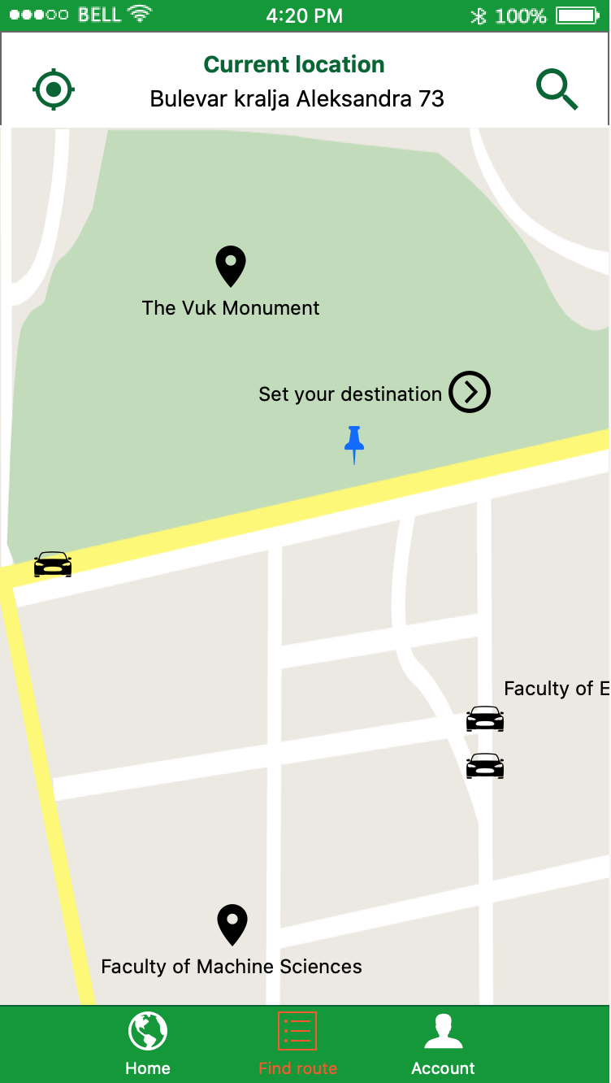

Set destination

Set current location manually

Current position

Set current location using GPS

1. Setting destination

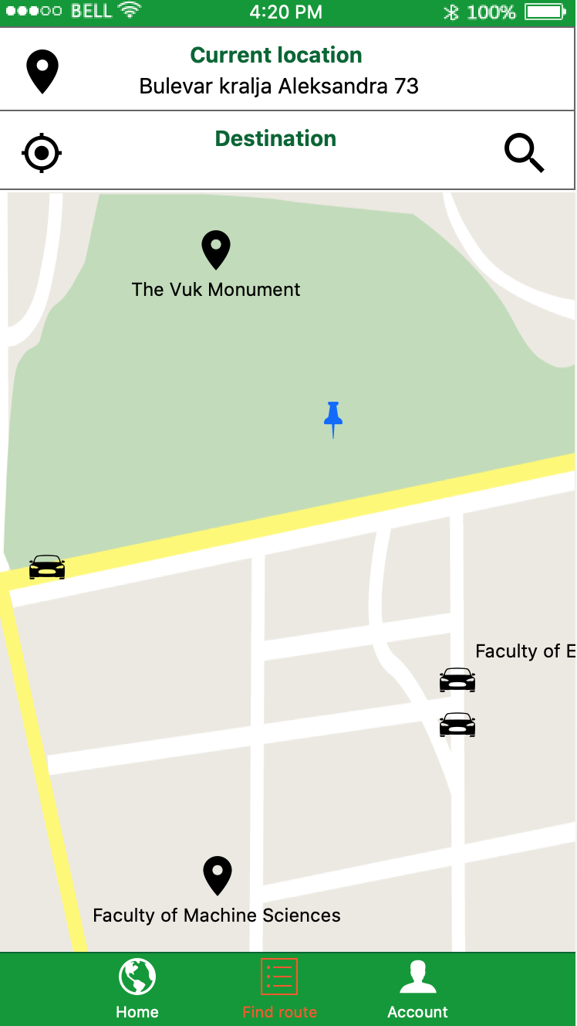

Set destination and go to the request page

Insert destination manually

1. 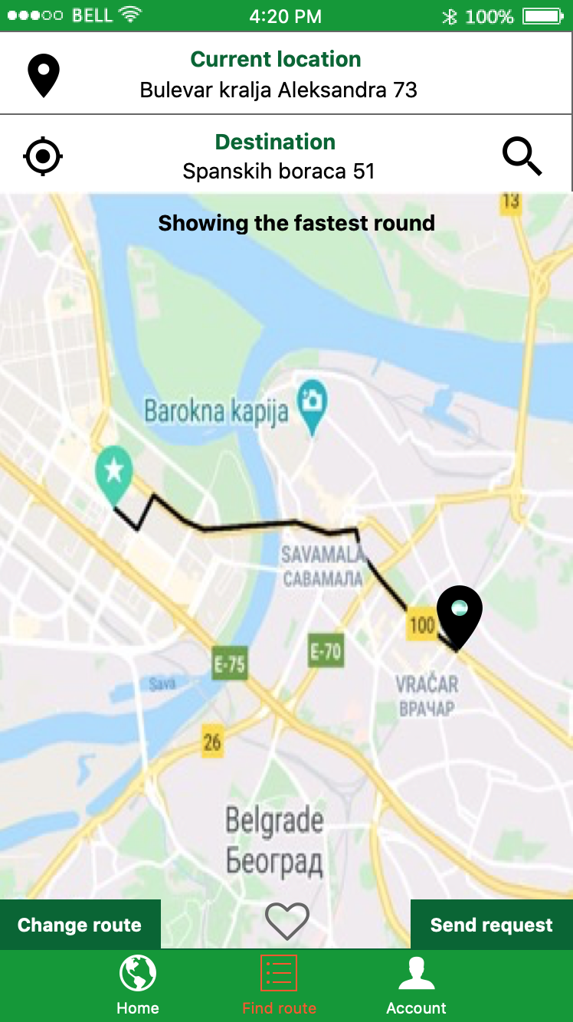Request page

Change route

Add this route to favourites

Send request for the given route

End point

Start point

Fastest eco route

Change destination

1. 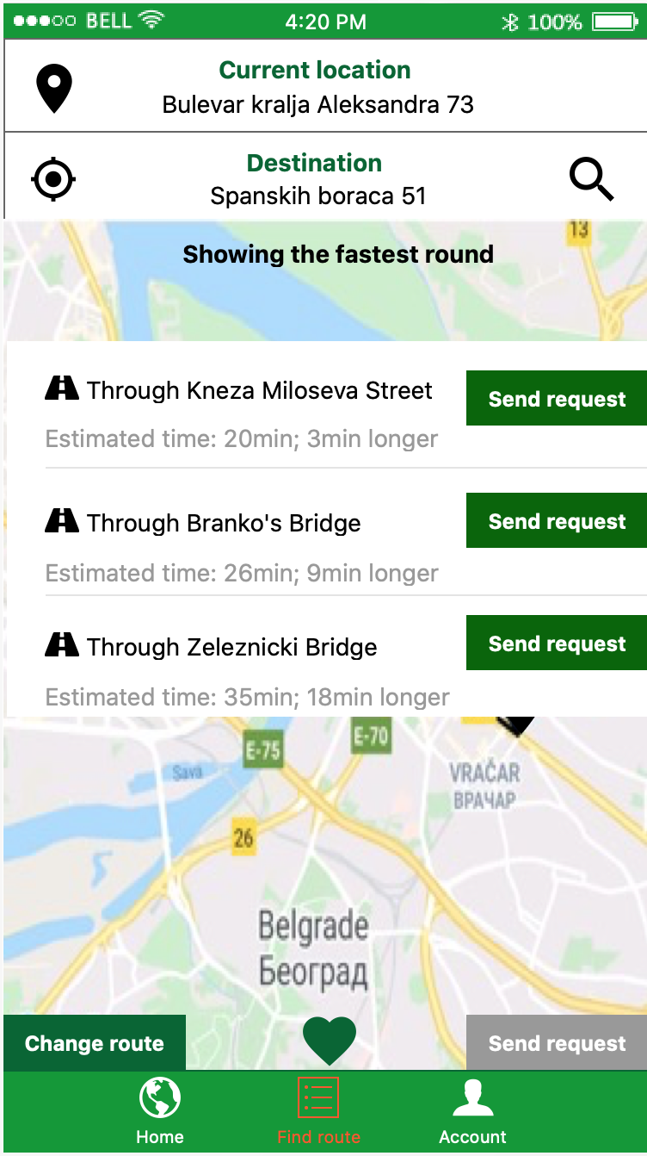Change route

Send new request

Remove this route from favourites

## 7.4 Change password

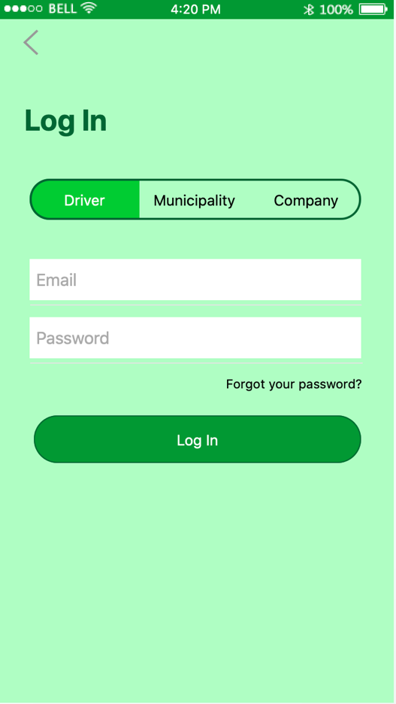

Insert account’s email

Change password

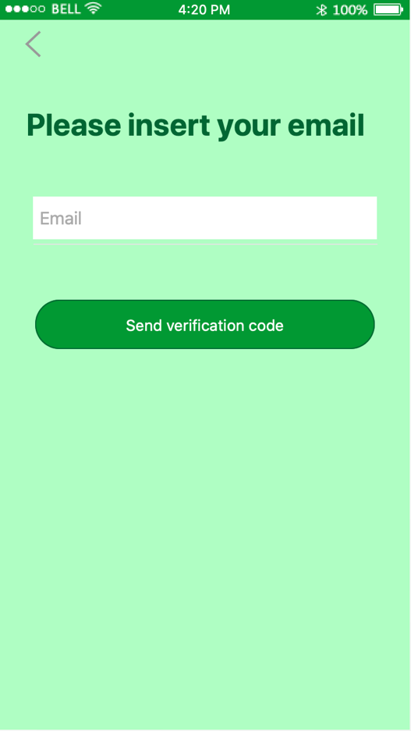

Send verification code to inputted email

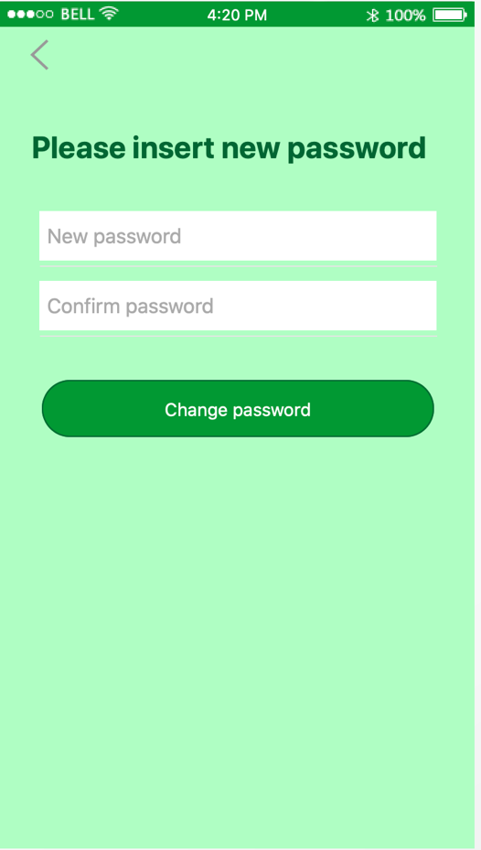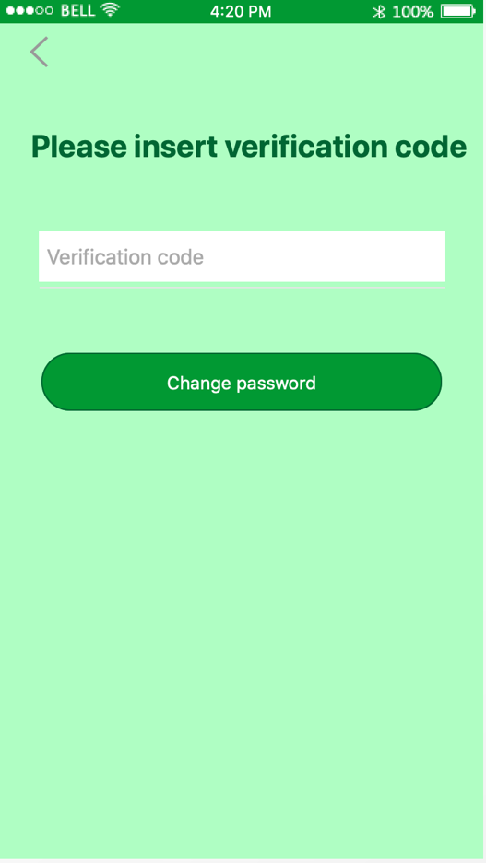

Confirm changed password

Confirm new password

Insert verification code from email

Insert new password

Click to input new password